جامعـة العلـوم التطبيقية الخاصة  كلية تكنولوجيا المعلومات  الواجب الأول - 02312    Student Name: Musaab Alfalahi  Student ID: 202020329  □ CS □ SE |  | APPLIED SCIENCE UNIVERSITY (ASU)  FACULTY OF INFORMATION TECHNOLOGY (FIT)  Assignmnet-2 2023-1  Subject: Software Development and Documentation  Instructor: Dr. Jalal Kiswani  Due Date: 30/ 12/ 2023
(5 marks)
- JavaDoc (3 POINTS)

- Create a simple Java class named SalaryCalculator, which contains one simple method called calculateSalary(int basic, int []Deductions, int []allownces) and returns the final salary. (1 POINT)
- Add JavaDoc for the above class and its method. (1 Points)
- Generate HTML Pages from the JavaDoc. (1 Points)

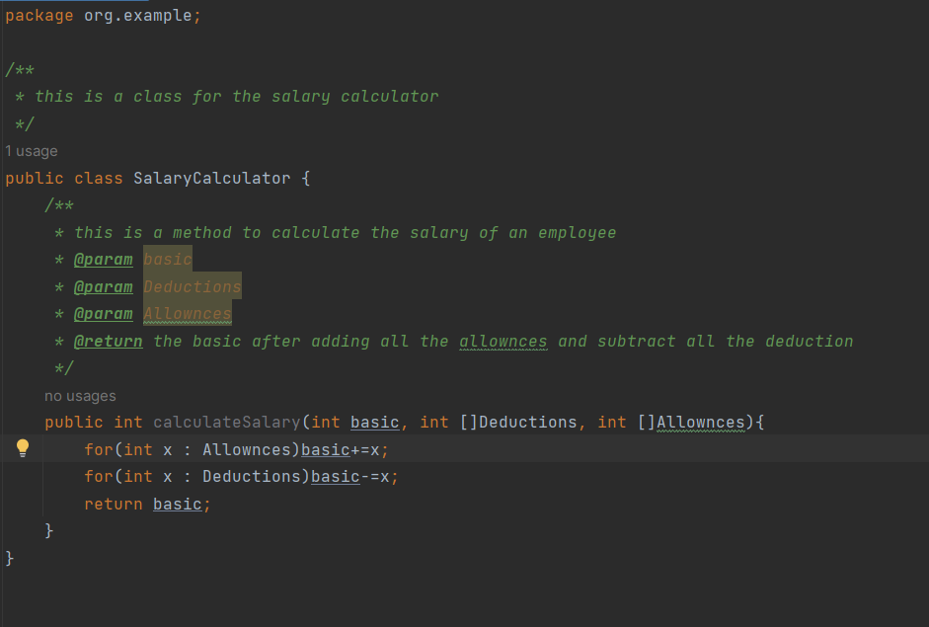
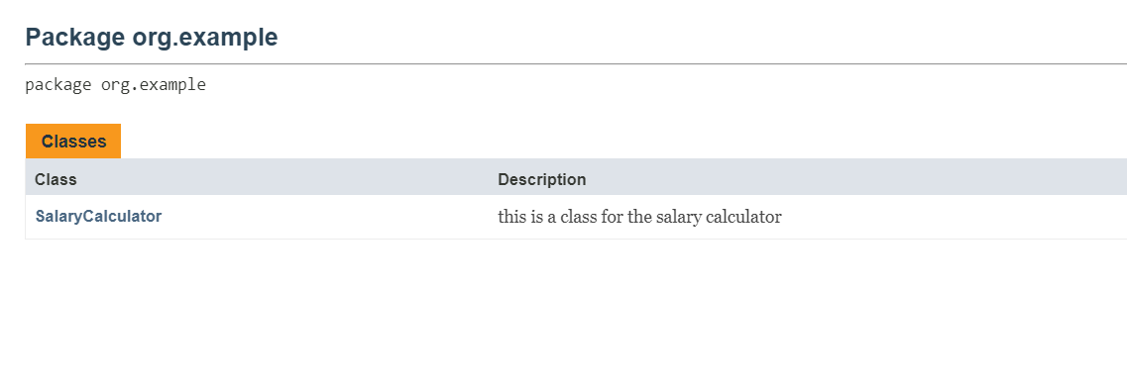
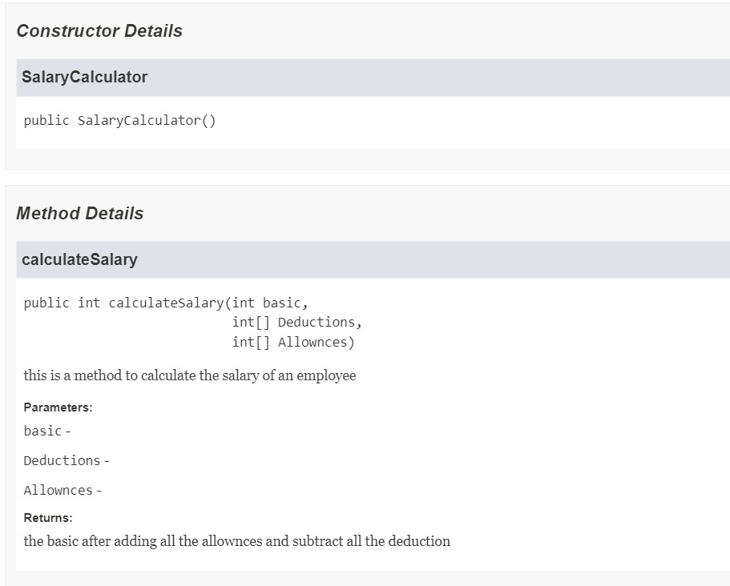

- Testing (2 POINTS)
Check MyASU for UI bugs and list at least 4 of them.

- Text out of border in the finance section
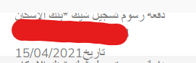

- Huge white space in GP1 course

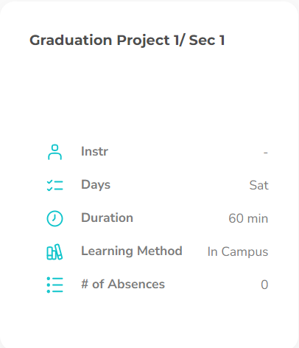

- İnstuctor name not fully written

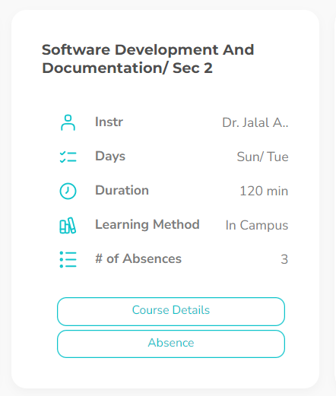

- Button overriding other texts

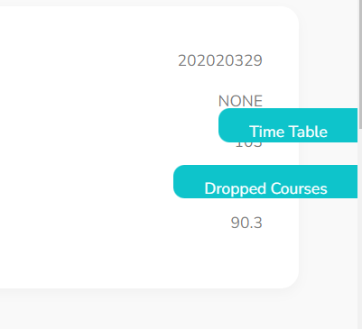

Instructions and Notes:
- Please submit your answer in.pdf format contains screenshots for your applications.
- This is an individual assignment. Any two identical answers will be graded ZERO automatically.
- You will be asked to EXPLAIN what you have submitted and your project will be evaluated on this basis
- Assignments submitted AFTER DUE DATE WILL NOT BE ACCEPTED.

Good Luck ☺

